**GoBack N and Selective Repeat protocol**

**GoBack N PROTOCOL**

**server_.java**

import java.io.*;

import java.net.*;

import java.util.*;

class server_{

public static void main(String args[])throws IOException{

System.out.println("...Server...");

System.out.println("...Waiting...");

InetAddress address = InetAddress.getByName("Localhost");

ServerSocket ss = new ServerSocket(500);

Socket s1 = new Socket();

s1 = ss.accept();

BufferedInputStream in = new BufferedInputStream(s1.getInputStream());

DataOutputStream out = new DataOutputStream(s1.getOutputStream());

System.out.println("received request for sending frames");

int n = in.read();

boolean[] array = new boolean[n];

int pc = in.read();

System.out.println("...Sending...");

if(pc==0){

for(int i=0;i<n;i++){

System.out.println("Sending frame => "+i);

out.write(i);

out.flush();

System.out.println("..Waiting for acknowledge..");

try{

Thread.sleep(5000);

}

catch (Exception e){}

int a = in.read();

System.out.println("received acknowledgment for frame => " +i+ " as "+a);

}

out.flush();

}

else{

for(int i=0;i<n;i++){

if(i==3) {

System.out.println("Sending frame number => " +i);

}

else{

System.out.println("sending frame no => " +i);

out.write(i);

out.flush();

System.out.println("Waiting for acknologment ");

try {

Thread.sleep(7000);

}

catch(Exception e){}

int a = in.read();

if(a!=255){

System.out.println("received ack for frame num =>"+i+" as "+a);

array[i]=true;

}

}

}

for(int a=0;a<n;a++){

if(array[a]==false){

System.out.println("Resending frame => " +a);

out.write(a);

out.flush();

System.out.println("waiting for ack ");

try {

Thread.sleep(5000);

}

catch(Exception e){}

int b = in.read();

System.out.println("receiving ack for frame num => "+a+" as "+b);

array[a]=true;

}

}

out.flush();

}

in.close();

System.out.println("Quiting");

}

}

**client_.java**

import java.io.*;

import java.net.*;

import java.math.*;

import java.util.*;

class client_{

public static void main(String args[]) throws IOException{

InetAddress address = InetAddress.getByName("Localhost");

System.out.println(address);

Socket s1 = new Socket(address,500);

BufferedInputStream in = new BufferedInputStream(s1.getInputStream());

DataOutputStream out = new DataOutputStream(s1.getOutputStream());

Scanner sc = new Scanner(System.in);

System.out.println("...client...");

System.out.println("Connect");

System.out.println("Enter the num of frames to be request to server");

int c = sc.nextInt();

out.write(c);

out.flush();

System.out.println("Enter type of trans. Error =1 : No Error=0");

int choice = sc.nextInt();

out.write(choice);

int i=0,j=0,check =0;

if(choice==0){

for(j=0;j<c;j++){

i = in.read();

System.out.println("receiver frame number => " +i);

System.out.println("Sending acknowlwdgement for frame number=> "+i);

out.write(i);

out.flush();

}

out.flush();

}

else{

for(j=0;j<c;j++){

i = in.read();

if(i==check){

System.out.println("i => " +i+ "check => " +check);

System.out.println("received frame number => "+i);

System.out.println("sending acknowledgement for frame num => " +i);

out.write(i);

check++;

}

else{

j--;

System.out.println("Discarded frame no => " +i);

System.out.println("Sending negative ack ");

out.write(-1);

}

out.flush();

}

}

in.close();

out.close();

System.out.println("Quiting");

}

}

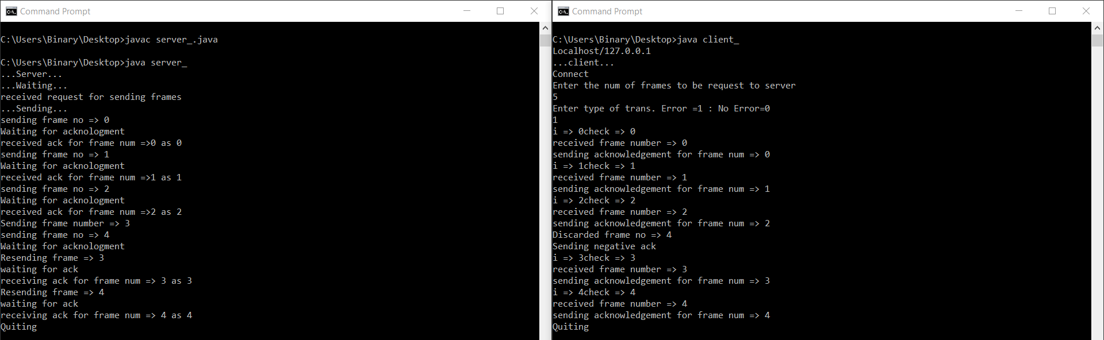

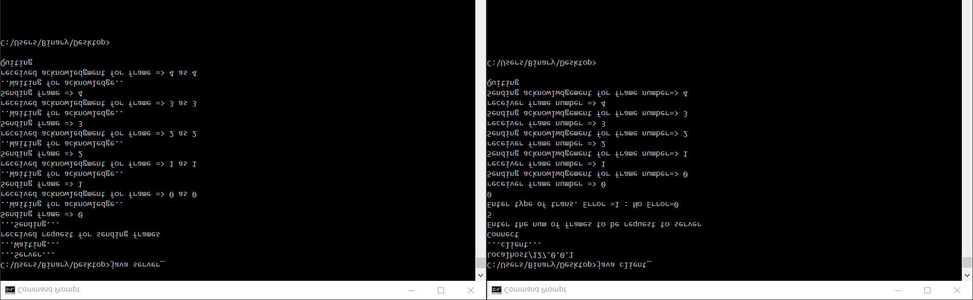

**SELECTIVE REPEAT PROTOCOL**

**server_selective.java**

import java.io.DataInputStream;

import java.io.DataOutputStream;

import java.io.IOException;

import java.net.ServerSocket;

import java.net.Socket;

import java.net.SocketException;

class server_selective

{

static ServerSocket Serversocket;

static DataInputStream dis;

static DataOutputStream dos;

public static void main(String[] args) throws SocketException

{

try

{

int a[] = { 30, 40, 50, 60, 70, 80, 90, 100 };

Serversocket = new ServerSocket(8011);

System.out.println("WAITING FOR CONNECTION");

Socket client = Serversocket.accept();

dis = new DataInputStream(client.getInputStream());

dos = new DataOutputStream(client.getOutputStream());

System.out.println("THE NUMBER OF PACKETS SENT IS :" + a.length);

int y = a.length;

dos.write(y);

dos.flush();

for (int i = 0; i < a.length; i++)

{

dos.write(a[i]);

dos.flush();

}

int k = dis.read();

dos.write(a[k]);

dos.flush();

}

catch (IOException e)

{

System.out.println(e);

}

finally

{

try

{

dis.close();

dos.close();

}

catch (IOException e)

{

e.printStackTrace();

}

}

}

}

**client_selective.java**

import java.lang.System;

import java.net.*;

import java.io.*;

import java.text.*;

import java.util.Random;

import java.util.*;

class client_selective {

static Socket connection;

public static void main(String a[]) throws SocketException {

try {

int v[] = new int[10];

int n = 0;

Random rands = new Random();

int rand = 0;

InetAddress addr = InetAddress.getByName("Localhost");

System.out.println(addr);

connection = new Socket(addr, 8011);

DataOutputStream out = new DataOutputStream(

connection.getOutputStream());

DataInputStream in = new DataInputStream(

connection.getInputStream());

int p = in.read();

System.out.println("NO OF FRAME IS :" + p);

for (int i = 0; i < p; i++) {

v[i] = in.read();

System.out.println(v[i]);

//g[i] = v[i];

}

rand = rands.nextInt(p);

v[rand] = -1;

for (int i = 0; i < p; i++)

{

System.out.println("RECEIVED FRAME IS: " + v[i]);

}

for (int i = 0; i < p; i++)

if (v[i] == -1) {

System.out.println("REQUEST TO RETRANSMIT FROM PACKET NO "+ (i+1) + " again!!");

n = i;

out.write(n);

out.flush();

}

System.out.println();

v[n] = in.read();

System.out.println("RECEIVED FRAME IS: " + v[n]);

System.out.println("QUITTING");

} catch (Exception e) {

System.out.println(e);

}

}

}

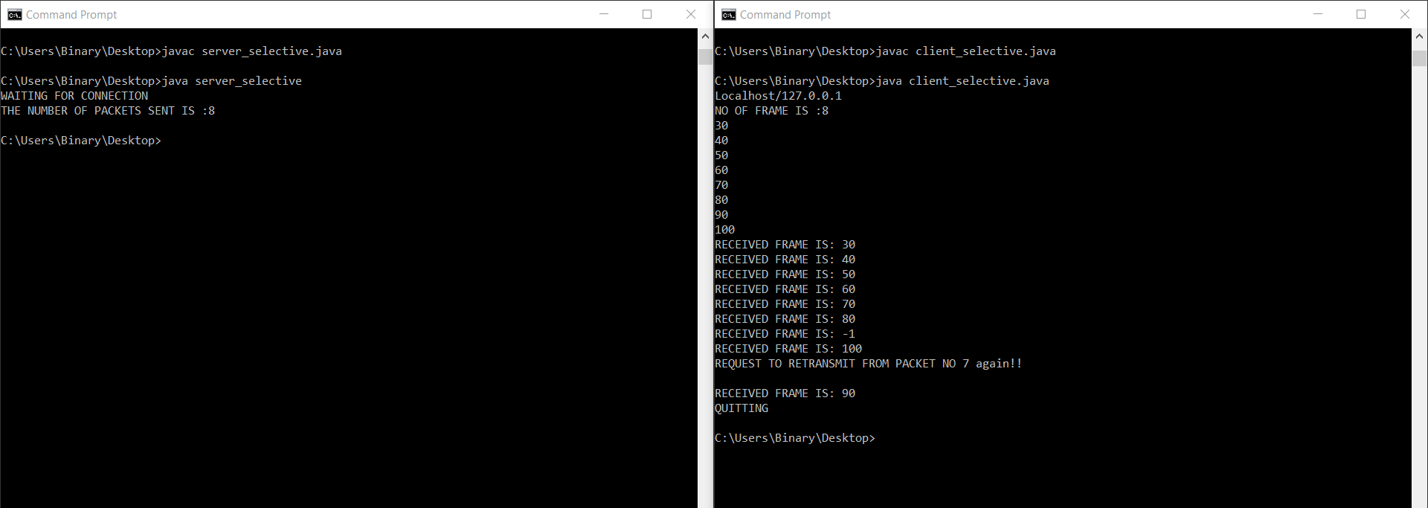

By,

Athmakuri V V L N Balaramacharyulu